GymLocation:

|  |  |  |  |  |  |
| --- | --- | --- | --- | --- | --- |
| LocationID | LocationName | Address | Tel | Email | VisitedTime |



Amenity:

|  |  |  |
| --- | --- | --- |
| AmenityID | LocationID(fk) | Amenity |

Certificate:

|  |  |  |
| --- | --- | --- |
| CertificateID | CoachID(FK) | CertificateName |



Coach:

|  |  |  |  |
| --- | --- | --- | --- |
| CoachID | CoachName | Level | Rating |



CoachLocation:

|  |  |  |
| --- | --- | --- |
| CoachLocationID | CoachID (FK) | LocationID (FK) |

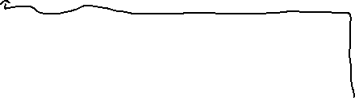

Review:

|  |  |  |  |  |  |  |
| --- | --- | --- | --- | --- | --- | --- |
| ReviewId | ReviewDate | Communication | Enthusiasm | Punctuality | Description | CoachID (FK) |

Reference:

|  |  |  |
| --- | --- | --- |
| ReferenceID | CoachID (FK) | ClientID (FK) |



Client:

|  |  |  |  |
| --- | --- | --- | --- |
| ClientID | ClientName | Email | Phone |

Class:

|  |  |  |  |  |  |  |
| --- | --- | --- | --- | --- | --- | --- |
| ClassID | Date | Time | ClassName | Price | Room | LocationID (fk) |